**MIDDLETON CHENEY FOOTBALL CLUB**

**ANNUAL GENERAL MEETING**

**2002**

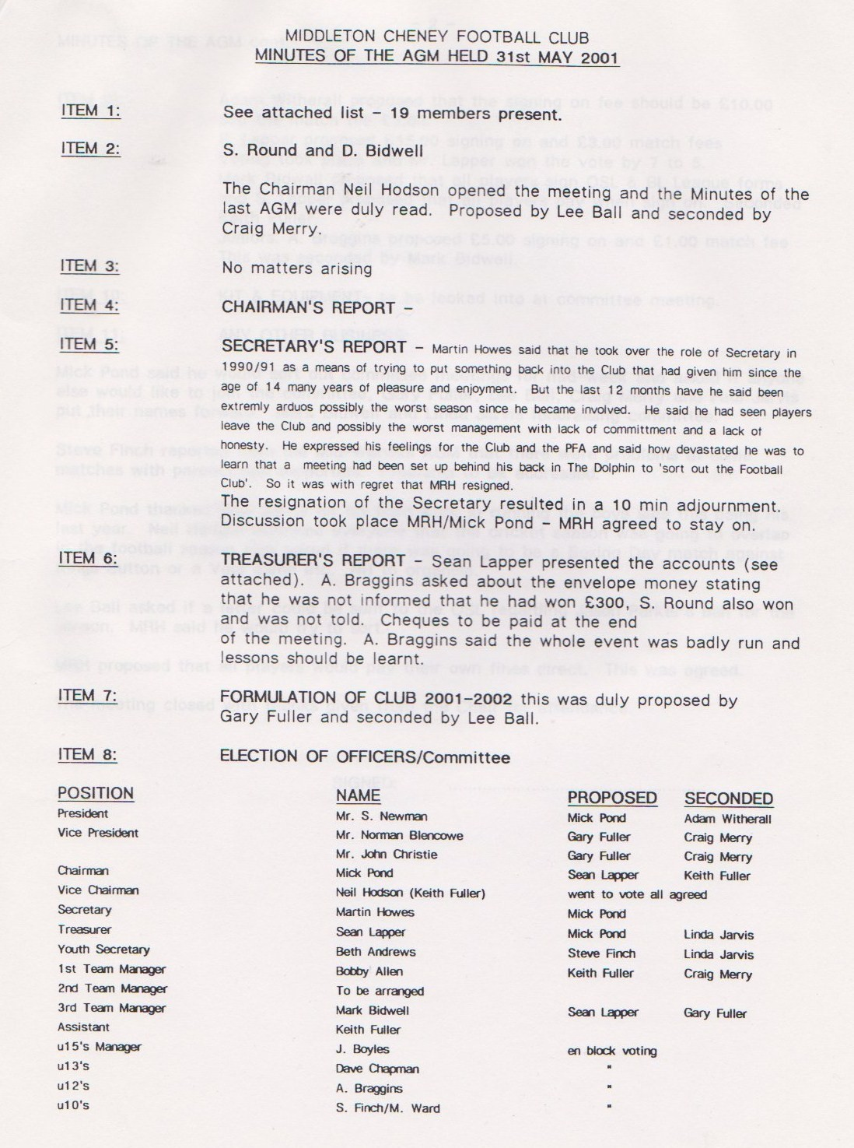

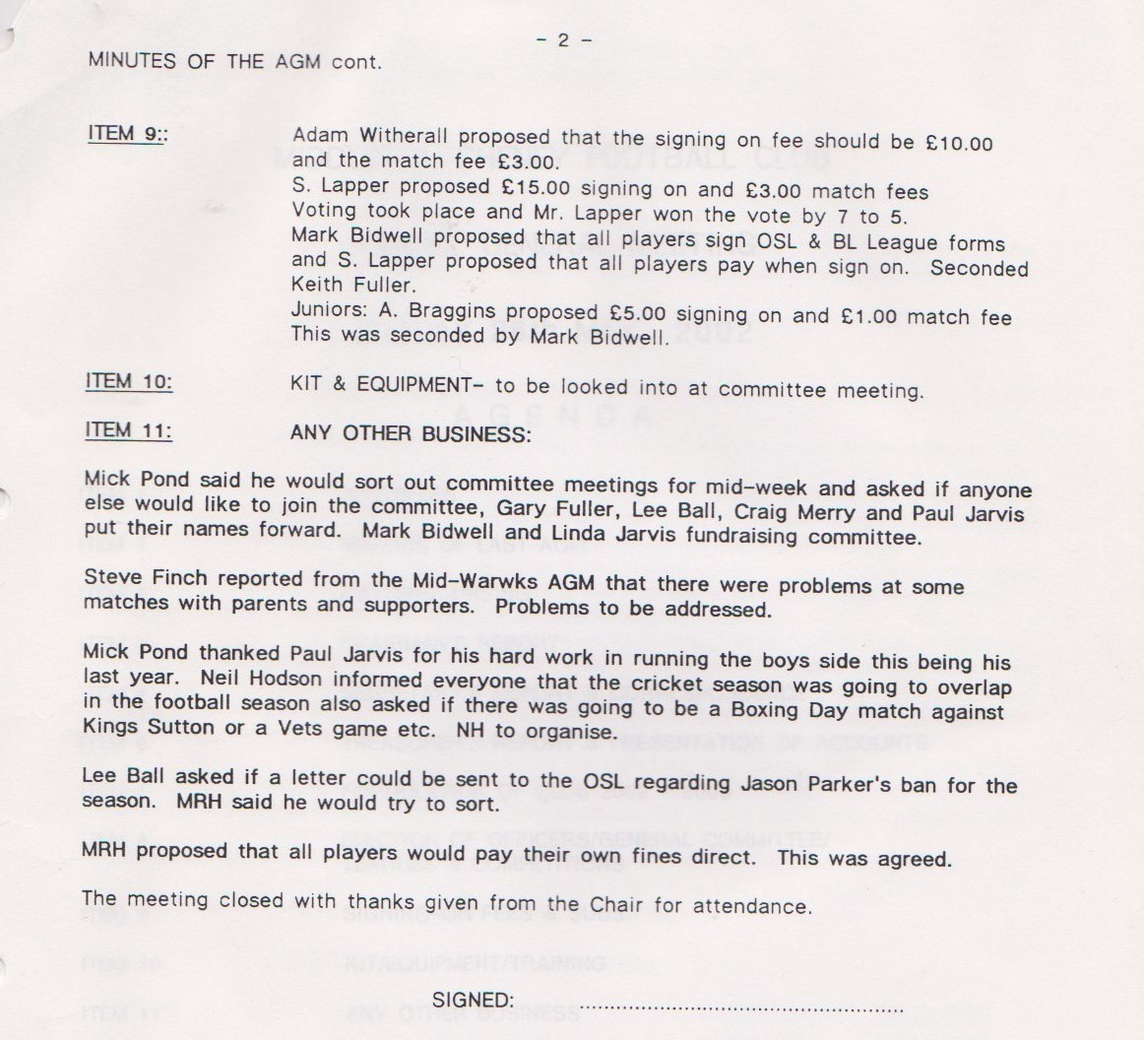

**General Committee Meeting**

**July 30th 2002**

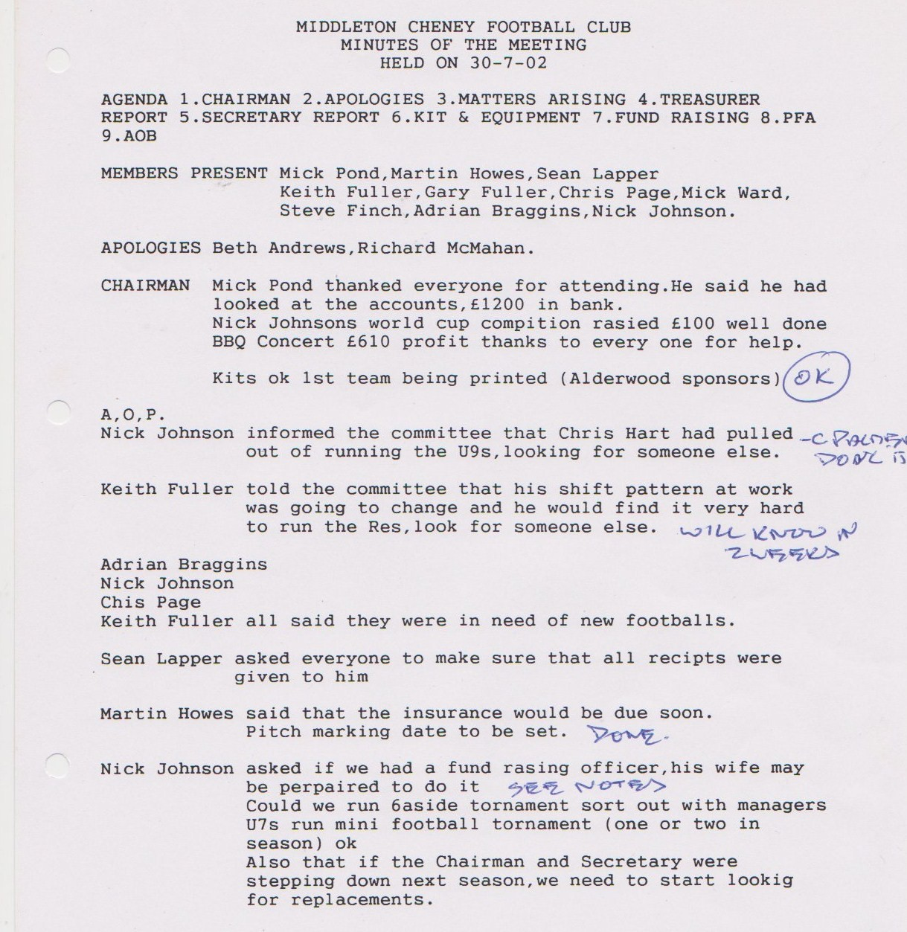

**News Letter**

**September 17th 2002**

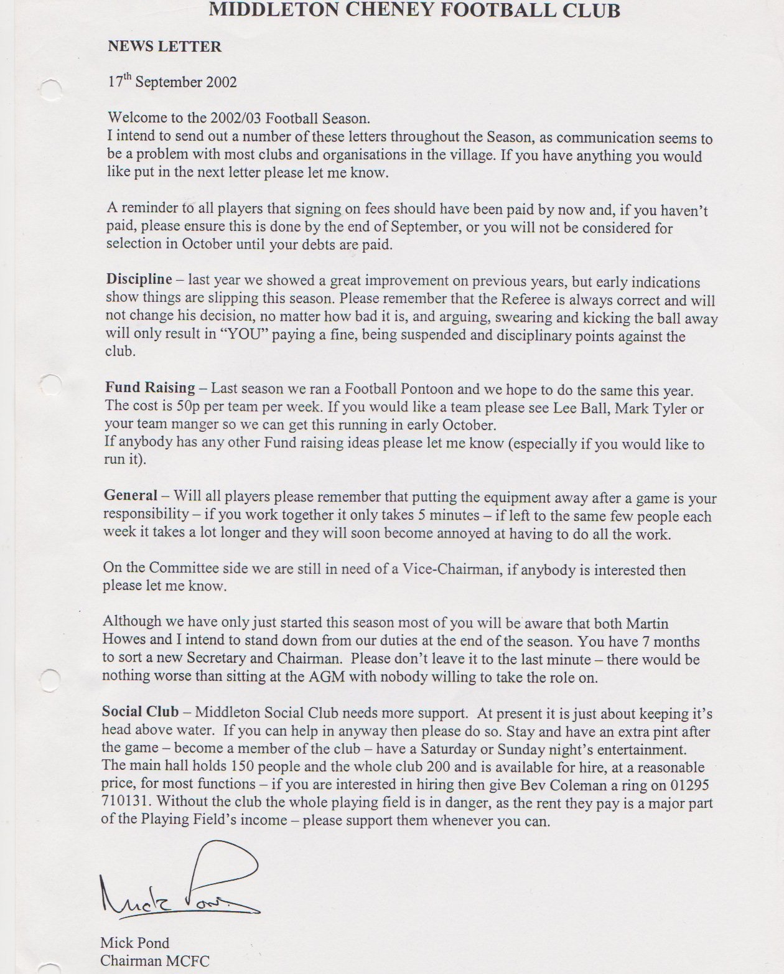

**General Committee Meeting**

**November 26th 2002**

